`

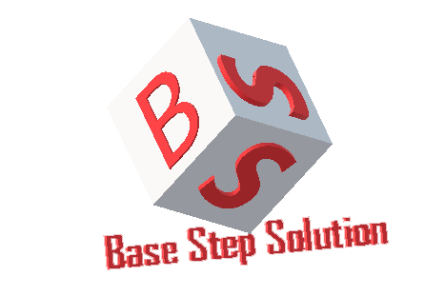

Meeting Minutes

Van Lang Admissions

# Revision Table

|  |  |  |  |
| --- | --- | --- | --- |
| **Author** | **Date** | **Reason for changes** | **Version** |
| Khoi Nguyen | 22/04/2017 | Initial Document | 1.0 |

Table of Contents

Revision Table 1

I. Purpose 3

II. Participant in meeting 3

III. Content of meeting 3

IV. To do task 3

|  |  |  |  |  |  |
| --- | --- | --- | --- | --- | --- |
| **Writer:** | Khởi Nguyễn | **Location:** | Floor 9, Etown 2 | | |
| **Date:** | 22/04/2017 | **Start:** | 13h30 | **Finish:** | 14h15 |

# Purpose

Discuss about Test Process

Track Redis & Elastic Search

# participant in meeting

Mentor Vũ Thế Nam

Team Capston:

* Nguyễn Thái Hiền
* Nguyễn Hoàng Anh Tài
* Đoàn Anh Minh
* Trần Xuân Hải
* Nguyễn Xuân Thái Hiền
* Nguyễn Anh Khởi

# Content of meeting

* Test process
* Redis & Elastic search
* Query statement
* REDIS use for category , banner , pop-ups
* Elastic search use for news , questions
* Don’t merge code
* Send mail = gmail
* Track estimate testcase

# To do task

* Complete execute testcases & report

---- *** ----